PROJECT REPORT

1.INTRODUCTION

1.1 Overview

Vidya’s Kitchen is the cupcake delivery store.We’re passionate about cupcakes,and love designing, making and delivering our delicious gifts and treats to happy people all around INDIA.We have about 40+ cupcake flavours.

1.2 Purpose

If you want to treat someone(or yourself) to our cupcakes,simply choose from extensive range of flavours and order online-your cupcakes will be delivered by courier the next day or another day of your choice.

2.LITERATURE SURVEY

2.1 Existing Problem

Online food delivery businesses are growing currently. When,we started researching on cupcakes business we got to know that there’s a lot of competition .The point where we felt difficult was,there was lack of growth in the business due to the less recognition of our cupcake store. Adding to that, the store was also located a lil far away from the residential areas.

While designing my website, I’ve learnt many new things such as what does domain actually mean. Definitions of website designing, URL,permalink,hosting etc,.

Specifically,working on wordpress was FUN. I’ve learned how websites are actually made using the features of wordpress. I got to know much about Themes,Templates,Widgets,Menus and many more…

2.2 Proposed Solution

For the problems stated above,better solutions can be to go digital. So,We started delivering our cupcakes to their doorstep so as location won’t be a problem anymore.To get recognised, we put Adds online to promote our brand and reach our customers.To attract customers we put offers during occasions and for existing customers we give huge discounts. To create traffic to our website we write interesting blogs with great content.

3.THEORETICAL ANALYSIS

3.1 Block Diagram

**SET YOUR GOALS**

**DELIVERY TO DOORSTEP**

**DIGITAL MARKETING**

**PLACING ADDS**

**SOLUTIONS**

**LOCATION OF STORE**

**LACK OF GROWTH**

**LESS RECOGNITION**

**PROBLEMS**

**CUPCAKE STORE**

**RESEARCH ON YOUR TOPIC**

**PLANNING**

3.2 Hardware/Software Designing

To do this project the most important thing we need is bitnami wordpress software so as to build our website using wordpress. We should have enough knowledge about the features of wordpress. Some of them include, pages,posts,menus,themes,templates and many.

To start with website,first we installed few plugins namely , elementor, elementor-header,footer & blocks, updraftplus-backup/restore,woocommerce and yoast seo which were updated recently and compatible with our version.

Then, the theme we selected is most widely used one called ASTRA.

To customise our website, we also use Menus for easy navigation using different different widgets.

Using the plugin elementor-header,footer & blocks we are able to create header and footer to our website using edit with elementor.

If we work on e-commerce website,then we need the plugin called woocommerce.

While building pages,we can use any template of our wish and customise it as per our design.

Using elementor, we will be able to write content,Title,insert images,audios,vedios etc into our page. We can style them as per our wish. In advanced section,we can change its typography,background colour or insert an image.we can also create a gallery for our website.elementor provides huge variety of features to design our website.

4.EXPERIMENTAL INVESTIGATIONS

While investigating about the business needs,strategies,planning,tactics and all.I got to know many new things. Some lead to problems and the other to ideas. When I planned to go digital, the first task was to design my website. I started exploring about features of wordpress to give a great layout to my website.Then,wordpress made it easier for me.during that period, I explored more about best theme to be used to make website user friendly.i gave a nice header,footer,menu and body to my website.i also added customized cupcakes for any kind of events. Cupcakes were categorized into by favour and by occasion as per customers choice. All these investigations made me lead to create a user friendly website.

5.FLOW CHART

Customer ordered

**RESTAURANT**

Order is made at store

**DELIVERY BOY**

order is handovered to  
delivery boy

order is delivered to  
the consumer

**CUSTOMER**

6.RESULT

Finally, I created a small cute website of cupcake shop consisting of 6 pages namely: landing page(homepage),About,Flavour,Ocassion,Blog and contact page using elementor.You find about 40 different flavors of cupcakes which u can order online and will be delivered at your doorstep.

The below Screenshots are the final outcome of my website.

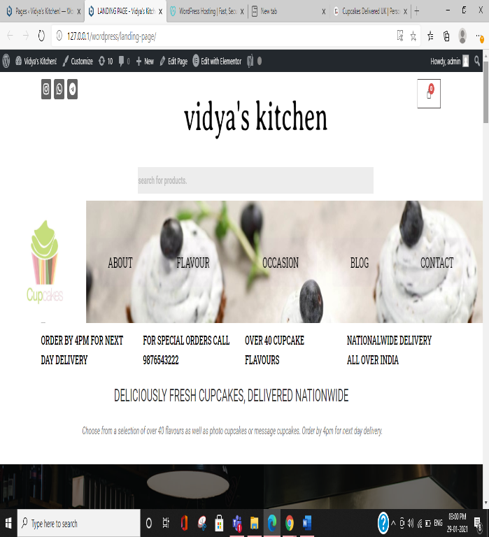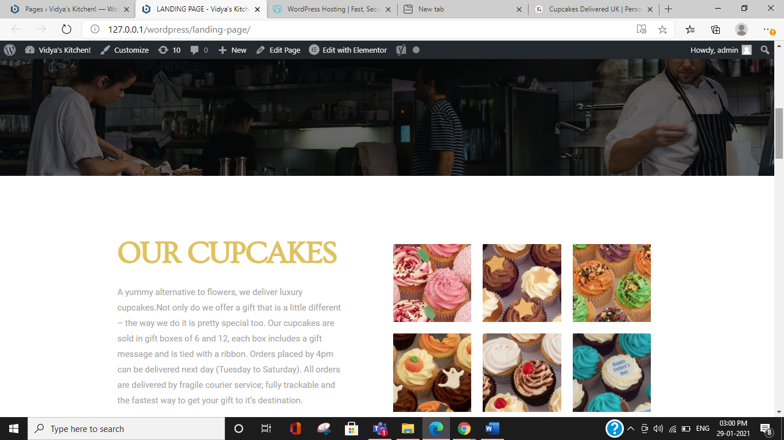

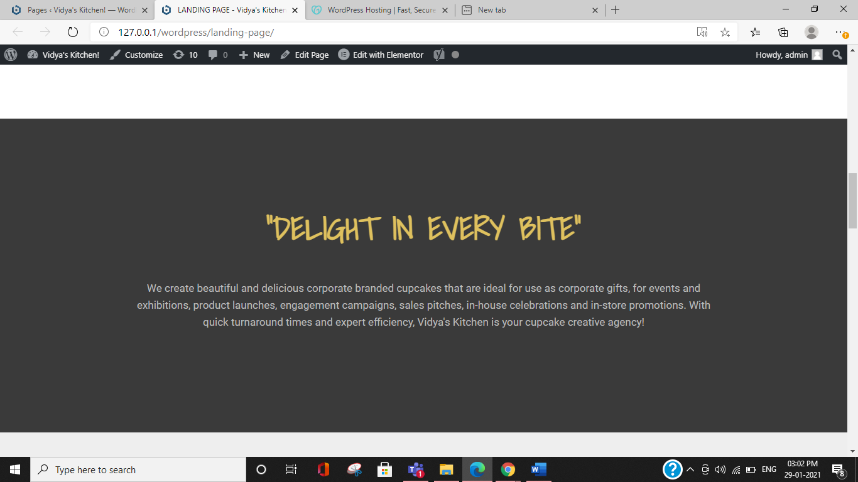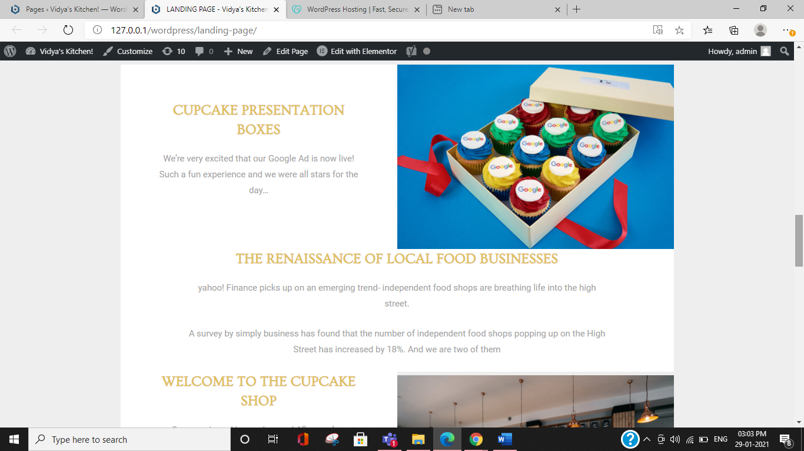

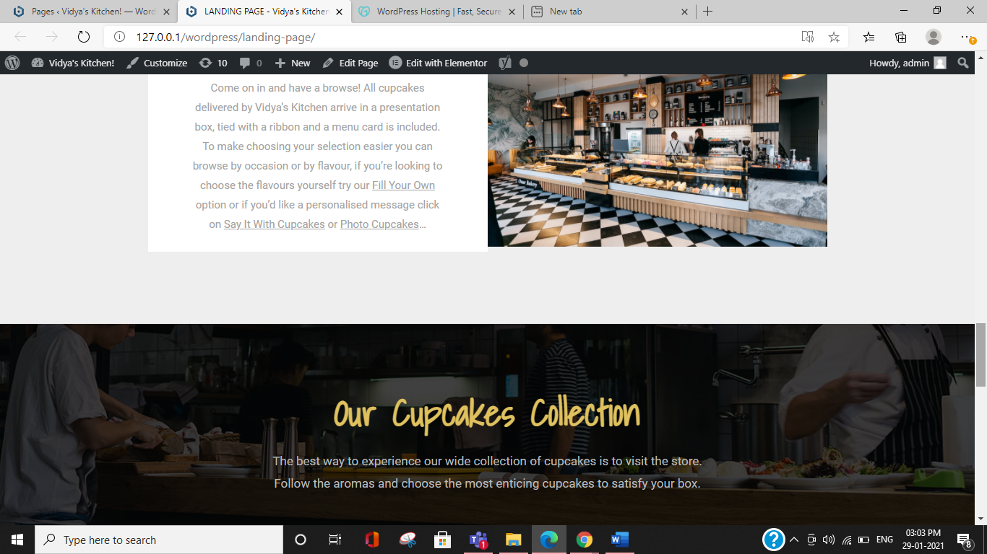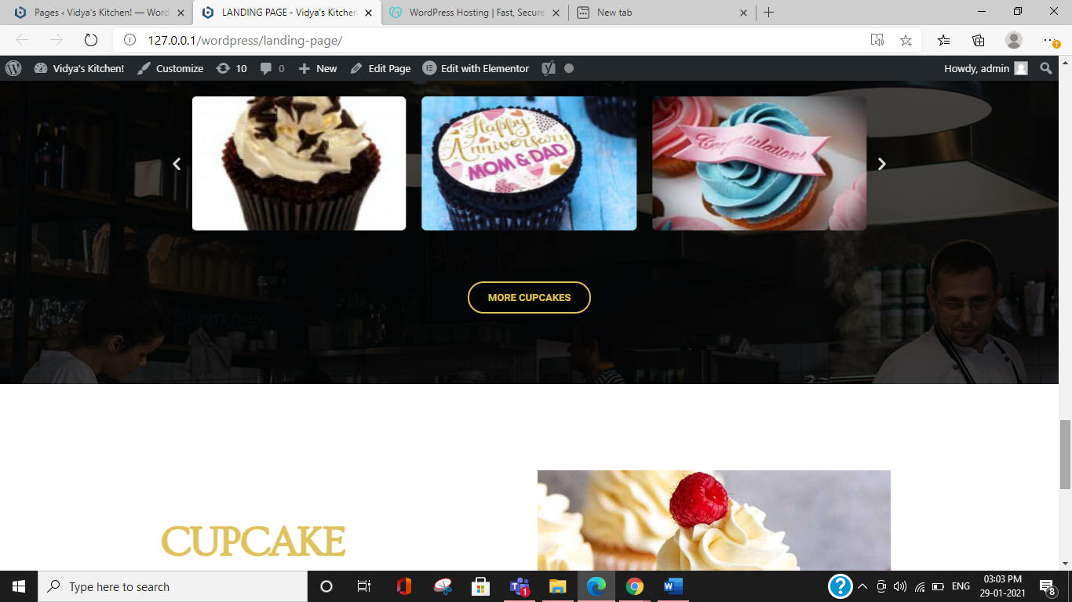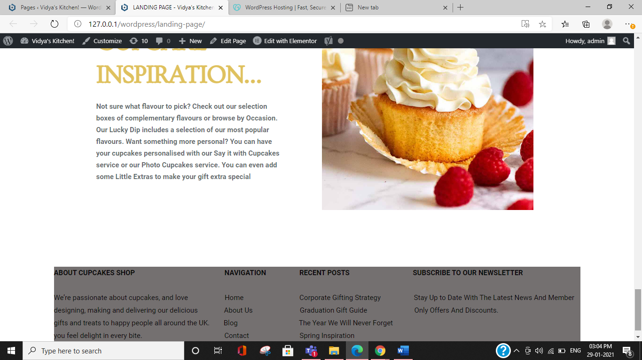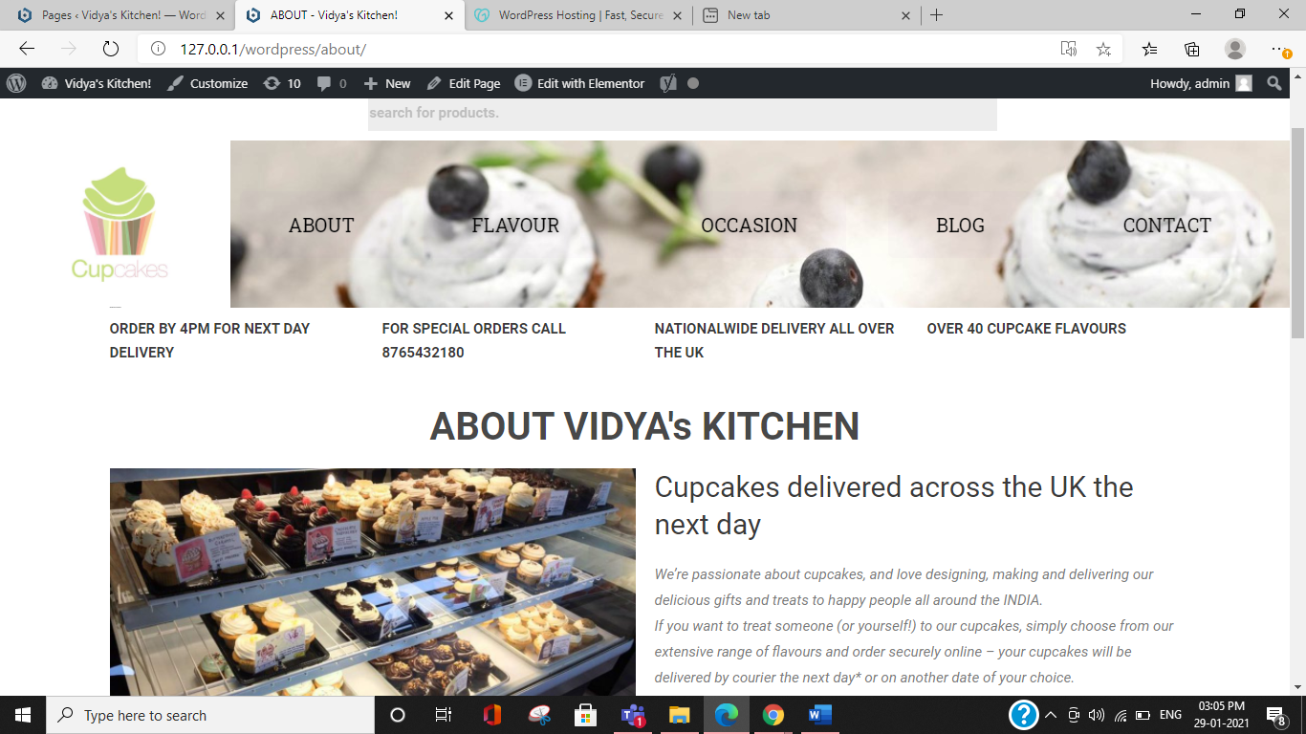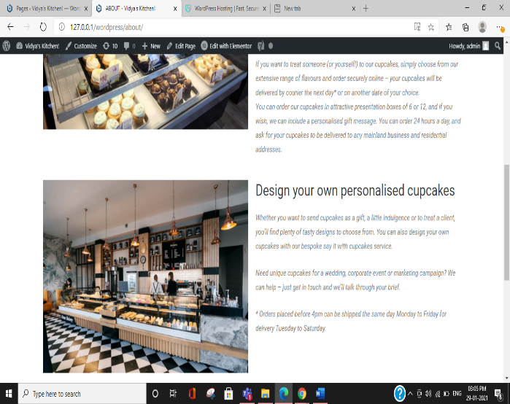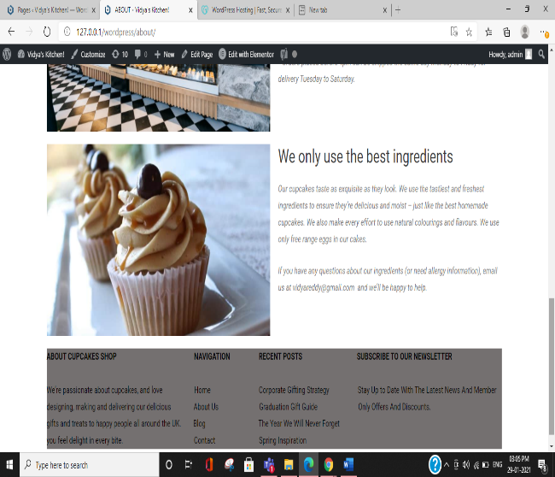

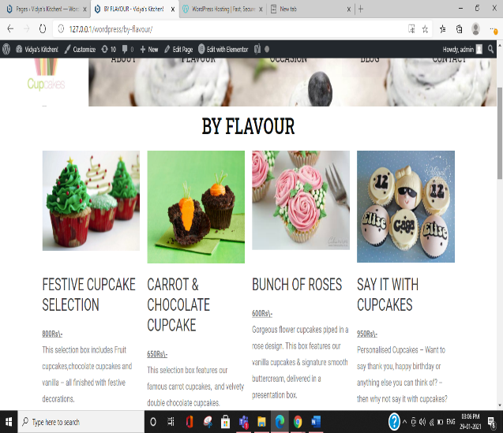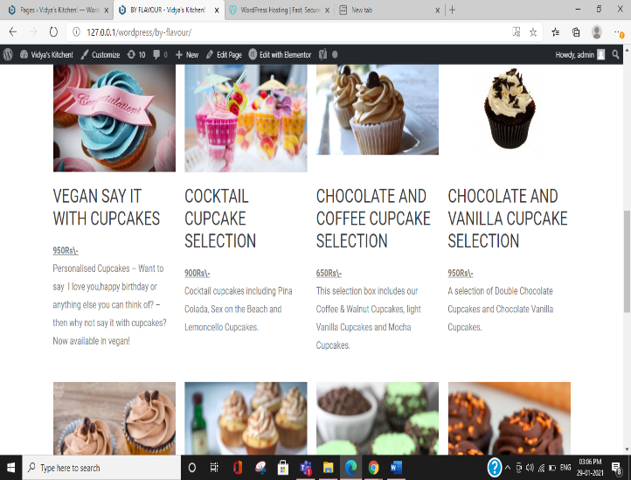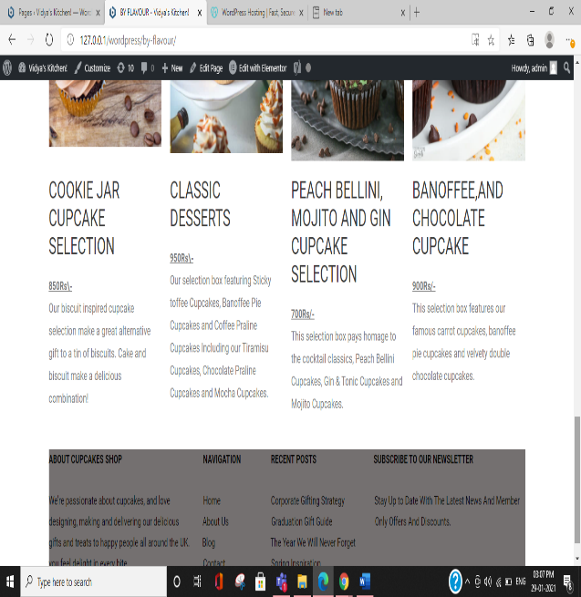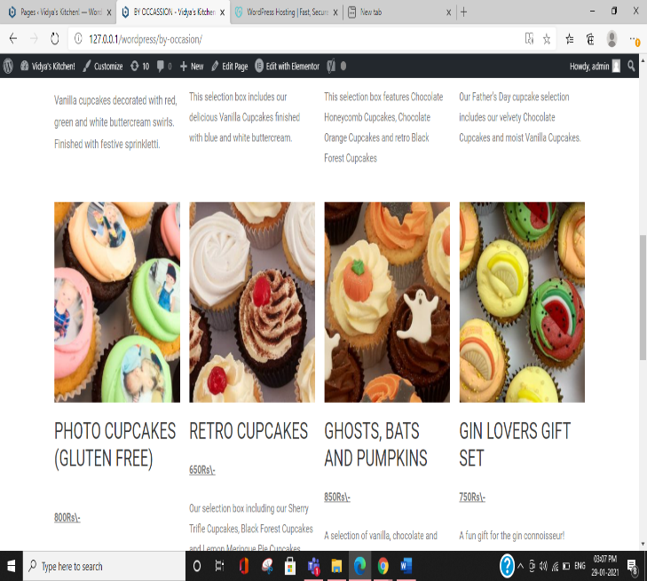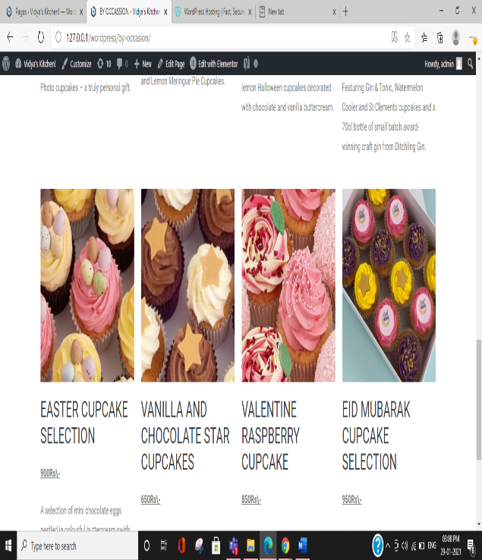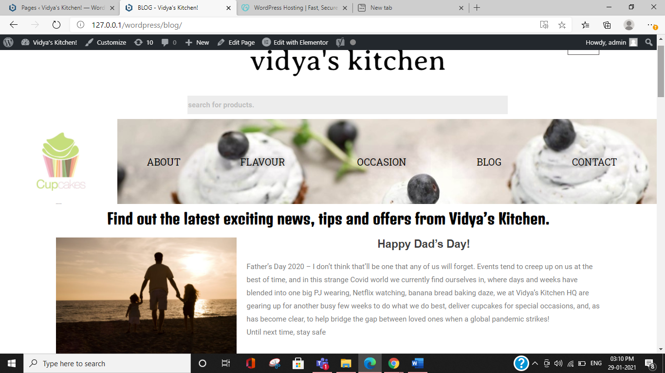

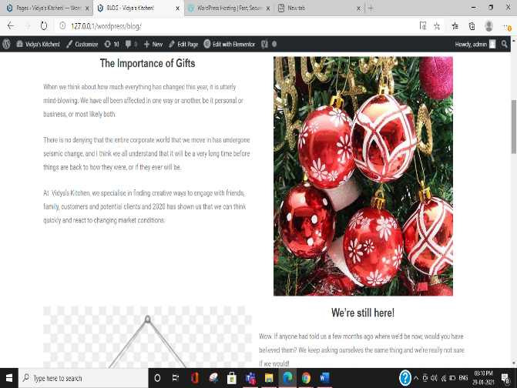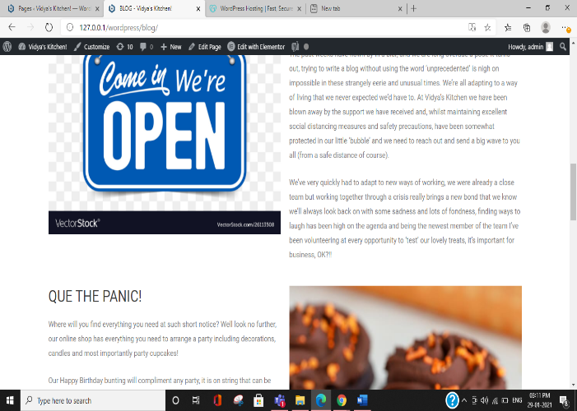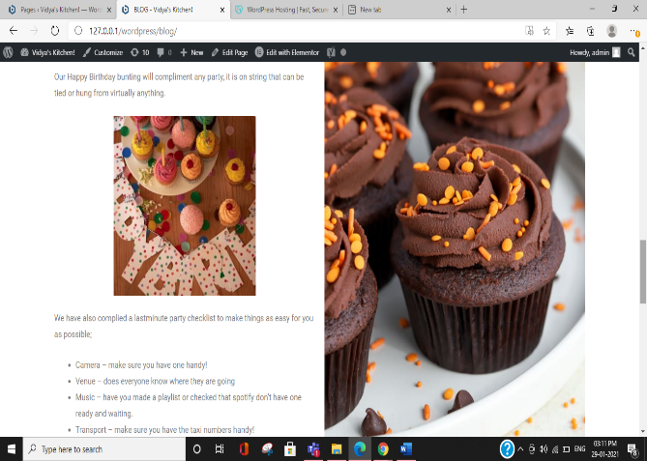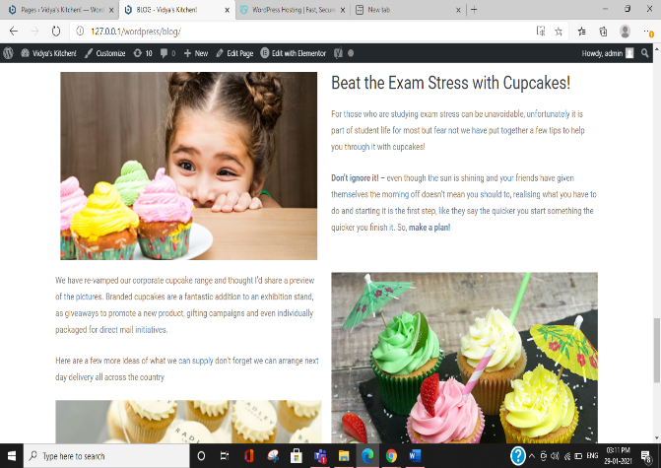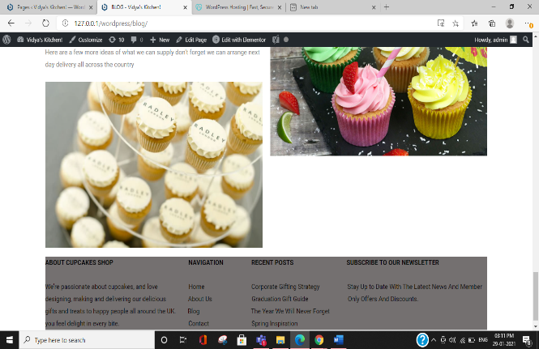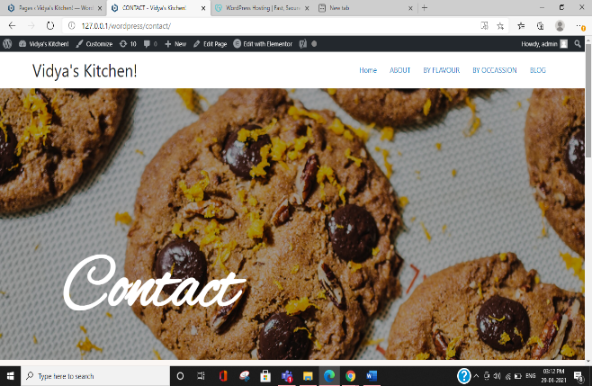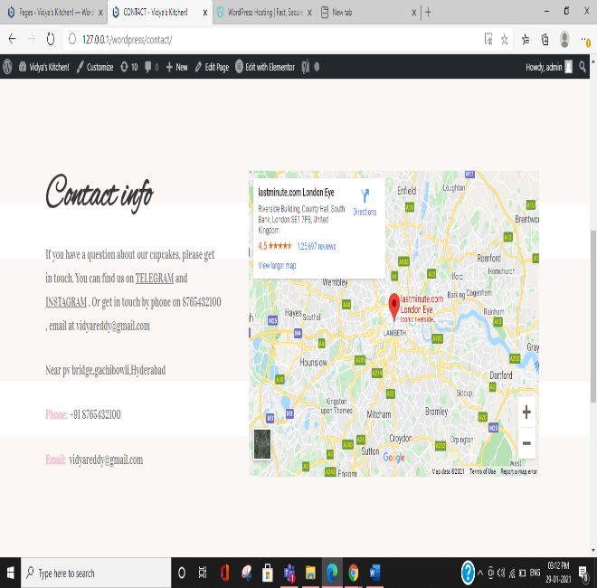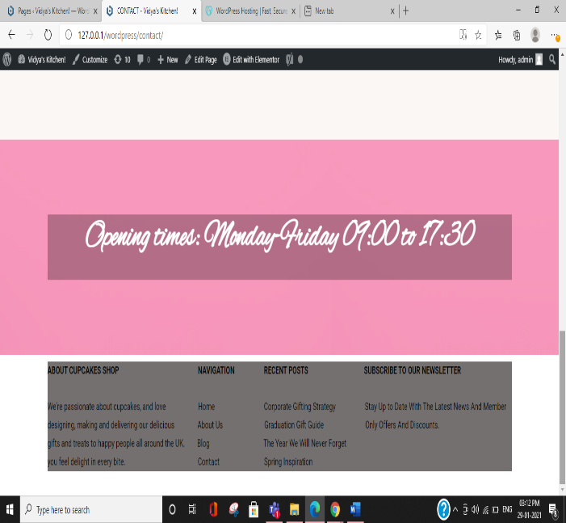

7.ADVANTAGES AND DISADVANTAGES

Solution givebn: digital marketing,placing adds,delivery to doorstep

ADVANTAGES:

1.Targeted audience can be reached in cost effective way.  
2.Brand loyalty  
3.Helps to get in contact with audience and get feedback  
4.Analytic tools can help show whats working for you and what not  
5.Makes the order processing easier  
6.Free and cheap marketing  
7.Grows your bottom line  
8.Increases traffic to your website

DiSADVANTAGES:

1.Not everyone is on the internet and wants to share data  
2.Limited space for Adds  
3.De-clining add clicks  
4.Revenue conflicts  
5.Juggling with your health

8.APPLICATIONS

The most common uses for digital marketing include social media management,content marketing and community building.

9.CONCLUSION

We make people feel delight in every bite. We deliver cupcakes to their doorstep. We make about 40 different cupcakes based on flavours and occasion. We also make customised corporate cupcakes.

10.FUTURE SCOPE

In future, we want our brand to be recognised by everyone and order our cupcakes for all the events which customers celebrate.

11.BIBILOGRAPHY

Took reference from rachels kitchen for layout and content for our website.